**Break-even Analysis**

One of the most important tools used to make better business decisions is the break-even analysis; it enables you to determine with great accuracy whether or not your idea is a profitable one. You can use this tool to evaluate every product or service you offer.

A break-even analysis is a simple way to determine how much of the product must be sold to generate a specific level of profitability. Each business has certain fixed costs that must be paid every month, whether or not any sales take place.

* Each product or service has variable costs that are incurred when the product is produced and sold.
* There are semi-variable costs that go up or down depending on the level of business activity.

After all costs attributable to bringing that product to market are deducted, each product or service yields a certain amount of profit. This profit contribution can then be divided into the "fixed costs" to determine how many units must be sold to break even.

Example - The total costs of operating a small cake bakery business each month are Rs.10,000. Each product the bakery produces can be sold for Rs.1,000. Each product costs an average of Rs. 800 per unit to produce, sell and deliver. The profit contribution per unit is therefore Rs. 200 each. The amount Rs. 200 is divided into Rs. 10,000 to determine the break-even point. Next, Rs. 10,000 divided by Rs. 200 equals 50 units. The company must therefore sell 50 units per month to break even, or approximately two units per business day. Only after the company has sold 50 units in one month does it begin to earn a profit of Rs. 200 per unit.

Conducting an accurate break-even analysis requires a careful examination and study of costs and prices in business. You must know what your product or service costs in total to deliver to the final customer, as well as the price you can charge for the product or service. Include and deduct all miscellaneous expenses involved in operating your business.

To begin, analyse every product or service you produce and sell on a regular basis. Make a list of these products or services, starting from the largest volume seller. Next, calculate the average sales price of each unit, and then calculate the total cost of each unit. Then, calculate the net profit that you earn on the sale of each unit, and calculate the cost of the investment to produce and sell each unit. Determine the percentage of return/profit that you earn from the sale of each unit.

It's important to organize each of the products and services by priority, in terms of their contribution to profitability. The analysis should be done on each of your important products or services. Begin by determining:

* Your single most profitable product or service.
* The volume of sales of each product.
* The total profit per unit of each product sold, after deducting every direct and indirect expense.
* The total profit contribution to the company of each product.

Many entrepreneurs decide to completely discontinue a product or service after conducting this kind of analysis. They immediately see that it would be better for them to invest their time and money in producing and selling something else.

As market conditions change and consumer desires evolve, you may find that a product or service that was once popular and profitable is no longer successful. It will then be time for you to begin offering a product or service that is easier to sell, sells at a higher price and yields a better profit.

**Definition**

Break-even analysis is a business tool widely used across all industries to evaluate business performance in terms of costs, since this is a supply-side analysis. Break-even analysis is an important aspect of a good business plan, since it helps the business determine the cost structures, and the number of units that need to be sold in order to cover the cost or make a profit. Break-even analysis is usually done as part of a business plan to see the how practical the business idea is, and whether or not it is worth pursuing. Even after a business has been set-up, break-even analysis can be immensely helpful in the pricing and promotion process, along with cost control.

Break-even point can be determined by calculating the point at which revenue received equals the total costs associated with the production of the goods or services.

Break-even Point = Fixed Costs/ (Unit Selling Price – Variable Costs)

**The Concept Behind the Analysis**

Using the above formula, the business can determine how many units it needs to produce in order to break-even. Once the business has reached this point, in sales or units sold, all costs (Fixed and Variable) have been recovered. Beyond this point, every additional unit sold will result in increasing profit for the business. The increase in profit will be by the amount of unit contribution margin, which is the amount of additional revenues that goes towards covering the fixed costs and profit. It can be [calculated](http://www.accountingcoach.com/break-even-point/explanation) as follow:

Unit Contribution Margin = Sales Price – Variable Costs

**Costs -** There are two distinct nature of costs that a business has to incur in its normal operational activities:

**Fixed Costs -** These costs stay the same regardless of how many units the company is producing. These include start-up costs, and other capital expenses which do not have to be paid periodically. Rent, insurance, utility bills and repairs are also considered fixed costs, since variations are minute and the amount does not directly depend on the number of items produced.

**Variable costs -** These costs are directly associated with the number of units produced, and these are recurring in nature, since they have to be paid periodically. As the business produces more and more goods and services, these costs increase proportional

**Revenue -** Revenue is the money that a business actually receives from its customers for the provisions of goods and services during a particular period. Discounts and deductions have already been adjusted, which means it is the gross income from which various costs are later deducted in order to calculate profit or loss. Total revenue can be calculated by multiplying the price at which goods or services are sold by number units sold.

**Contribution Margin -** Contribution margin can be calculated by subtracting variable expenses from the revenues. The contribution margin shows how much of the company’s revenues will be contributing towards covering the fixed costs. It can be expressed on per unit basis or for the total amount. It can also be expressed as a percentage of net sales.

**Application of Break-even Analysis**

**Cost Calculation -** Break-even analysis is widely used to determine the number of units the business needs to sell in order to avoid losses. This calculation requires the business to determine selling price, variable costs and fixed costs. Once these numbers are determined, it is fairly easy to calculate break-even point in units or sales value.

**Budgeting and Setting Targets -** Break-even charts and calculation be used for budgeting process, since the business know exactly how many units need to be sold in order to break-even. Moreover, the company is also aware of the profits the company will be able to earn at various points, which can be easily illustrated on a simple break-even chart. This can help business set realistic, achievable targets for itself.

**Motivational Tool -** Break-even analysis also helps to motivate the employees, especially the sales staff, since it clearly shows the profits at various points of sales. The chart clearly shows the impact extra sales would have on the profitability of the company.

**Margin of Safety -** [Margin of safety](https://www.google.com.pk/url?sa=t&rct=j&q=&esrc=s&source=web&cd=1&cad=rja&uact=8&ved=0CBsQFjAA&url=http%3A%2F%2Faccountingexplained.com%2Fmanagerial%2Fcvp-analysis%2Fmargin-of-safety&ei=J31HVNa6Ceuf7gbh44DQDg&usg=AFQjCNGRqKGH_S0gA2mtfbMpCb_c5TOeRQ&sig2=jCu2u-8QQ1eMzV8470pbww&bvm=bv.77880786,d.ZGU) is a tool which complements break-even analysis, since these tools are interrelated. This concept is used when a major proportion of sales are likely to decline or in period of recession or economic turn down. Managers can make better production and sales decision if they know the margin of safety for a particular product or service. When the margin of safety is large, the business would want to try new pricing, marketing and take risks hoping to further increase sales and revenues. On the other hand, if the margin of safety is meager, managers are likely not to change anything, since any small change could trigger losses. In such a situation, managers would want to reduce costs, so that margin of safety can be increased.

The concept of margin of safety might not be useful for businesses with seasonal demand for their products or services, since there will be a lot of variations on monthly basis. The result could be complied for an entire year, so that seasonal fluctuations are removed.

**Cost Control and Monitoring -** Since costs (Fixed and Variable) affect the profitability of the business directly, the managers can easily see these changes through break-even analysis. This would help them control costs, and make sure that they remain within a given range.

**Helps devise a pricing strategy -** Selling price is an important determinant of break-even analysis. If managers have access to break-eve charts, they will be able to see the impact, changes in selling price has on the overall profitability. Hence, this tool provides more information for the mangers to make better pricing decision, considering the supply-side of the production process

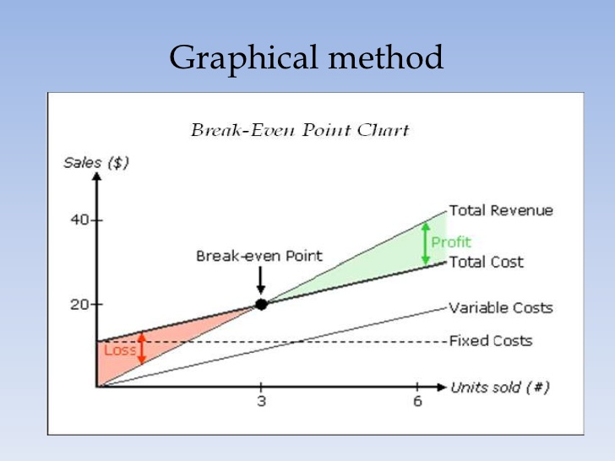

Break-even analysis is a technique widely used by production management and management accountants. It is based on categorising production costs between those which are "variable" (costs that change when the production output changes) and those that are "fixed" (costs not directly related to the volume of production).

Total variable and fixed costs are compared with sales revenue in order to determine the level of sales volume, sales value or production at which the business makes neither a profit nor a loss (the "break-even point").

**The Break-Even Chart**

In its simplest form, the break-even chart is a graphical representation of costs at various levels of activity shown on the same chart as the variation of income (or sales, revenue) with the same variation in activity. The point at which neither profit nor loss is made is known as the "break-even point" and is represented on the chart below by the intersection of the two lines:

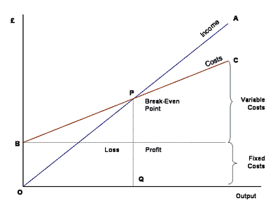

In the diagram above, the line OA represents the variation of income at varying levels of production activity ("output"). OB represents the total fixed costs in the business. As output increases, variable costs are incurred, meaning that total costs (fixed + variable) also increase. At low levels of output, Costs are greater than Income. At the point of intersection, P, costs are exactly equal to income, and hence neither profit nor loss is made.

**Fixed Costs**

Fixed costs are those business costs that are not directly related to the level of production or output. In other words, even if the business has a zero output or high output, the level of fixed costs will remain broadly the same. In the longterm fixed costs can alter - perhaps as a result of investment in production capacity (e.g. adding a new factory unit) or through the growth in overheads required to support a larger, more complex business.

***Examples of fixed costs:*** Rent and rates, Depreciation, Research and development, Marketing costs (non- revenue related), Administration costs

**Variable Costs** - Variable costs are those costs which vary directly with the level of output. They represent payment output-related inputs such as raw materials, direct labour, fuel and revenue-related costs such as commission.

A distinction is often made between **Direct** variable costs and **Indirect** variable costs.

**Direct** variable costs are those which can be directly attributable to the production of a particular product or service and allocated to a particular cost centre. Raw materials and the wages those working on the production line are good examples.

**Indirect** variable costs cannot be directly attributable to production but they do vary with output. These include depreciation (where it is calculated related to output - e.g. machine hours), maintenance and certain labour costs.

**Semi-Variable Costs** - There are some costs which are fixed in nature but which increase when output reaches certain levels. These are largely related to the overall "scale" and/or complexity of the business. For example, when a business has relatively low levels of output or sales, it may not require costs associated with functions such as human resource management or a fully-resourced finance department. However, as the scale of the business grows (e.g. output, number people employed, number and complexity of transactions) then more resources are required. If production rises suddenly then some short-term increase in warehousing and/or transport may be required. In these circumstances, we say that part of the cost is variable and part fixed.

Problem - From the data given below, Calculate the following

1. Break Even Point in sales value
2. Number of units that must be sold to earn a profit of Rs. 90,000.

**[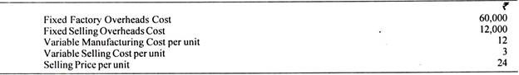](http://cdn.accountingnotes.net/wp-content/uploads/2016/06/clip_image012_thumb2-2.jpg)**

**[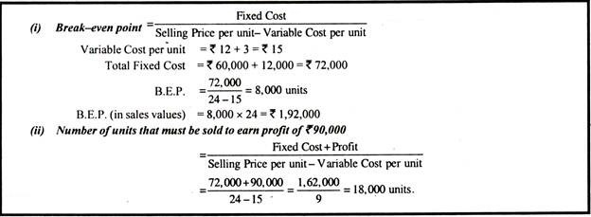](http://cdn.accountingnotes.net/wp-content/uploads/2016/06/clip_image013_thumb2.jpg)**

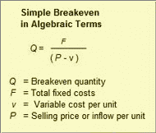

The simple break-even formula shows how these inputs produce the break-even quantity ***Q***. Suppose, for instance, a firm produces and sells a product with these values:

***F*** = Total Fixed costs = Rs. 1,200

***v*** = Variable cost per unit = Rs. 15

***P*** = Selling price per unit = Rs. 40

The formula finds the break-even number of units—**break-even point**—as follows:

*Q* = (1,200) / (40 – 15)

    = 1,200 / 25

    = 48 units

Knowing the break-even quantity **Q**, the analyst verifies the result by comparing total inflows to total outflows.

Total Inflows

      = *Q * P* = (48) ( Rs 40) = Rs. 1,920

Total Costs

     = Fixed costs + Variable costs

     = *F* + (*Q* * *v*) = Rs 1,200 + (48)(Rs. 15) = Rs. 1,920

Sometimes the break-even result includes a fractional unit (for example, 50.34 units). No one sells or ships fractional units, however. In such cases, of course, the analyst rounds break-even quantity **Q** *up* to the next whole unit (to 51 units).

**Ratio Analysis**

Ratio Analysis is a form of Financial Statement Analysis that is used to obtain a quick indication of a firm's financial performance in several key areas. The ratios are categorized as Short-term Solvency Ratios, Debt Management Ratios, Asset Management Ratios, Profitability Ratios, and Market Value Ratios.

Ratio Analysis as a tool possesses several important features. The data, which are provided by financial statements, are readily available.

The computation of ratios facilitates the comparison of firms which differ in size. Ratios can be used to compare a firm's financial performance with industry averages. In addition, ratios can be used in a form of trend analysis to identify areas where performance has improved or deteriorated over time.

Because Ratio Analysis is based upon Accounting information, its effectiveness is limited by the distortions which arise in financial statements due to such things as Historical Cost Accounting and inflation. Therefore, Ratio Analysis should only be used as a first step in financial analysis, to obtain a quick indication of a firm's performance and to identify areas which need to be investigated further.

**Short-term Solvency or Liquidity Ratio -** Short-term Solvency Ratios attempt to measure the ability of a firm to meet its short-term financial obligations. In other words, these ratios seek to determine the ability of a firm to avoid financial distress in the short-run. The two most important Short-term Solvency Ratios are the Current Ratio and the Quick Ratio.

Current Ratio **-** The Current Ratio is calculated by dividing Current Assets by Current Liabilities. Current Assets are the assets that the firm expects to convert into cash in the coming year and Current Liabilities represent the liabilities which have to be paid in cash in the coming year. The appropriate value for this ratio depends on the characteristics of the firm's industry and the composition of its Current Assets. However, at a minimum, the Current Ratio should be greater than one.

Quick Ratio **-** The Quick Ratio recognizes that, for many firms, Inventories can be rather illiquid. If these Inventories had to be sold off in a hurry to meet an obligation the firm might have difficulty in finding a buyer and the inventory items would likely have to be sold at a substantial discount from their fair market value.

This ratio attempts to measure the ability of the firm to meet its obligations relying solely on its more liquid Current Asset accounts such as Cash and Accounts Receivable. This ratio is calculated by dividing Current Assets less Inventories by Current Liabilities.Bottom of Form

**Debt Management Ratios -** Debt Management Ratios attempt to measure the firm's use of Financial Leverage and ability to avoid financial distress in the long run. These ratios are also known as Long-Term Solvency Ratios.

Debt is called Financial Leverage because the use of debt can improve returns to stockholders in good years and increase their losses in bad years. Debt generally represents a fixed cost of financing to a firm. Thus, if the firm can earn more on assets which are financed with debt than the cost of servicing the debt then these additional earnings will flow through to the stockholders. Moreover, our tax law favours debt as a source of financing since interest expense is tax deductible.

With the use of debt also comes the possibility of financial distress and bankruptcy. The amount of debt that a firm can utilize is dictated to a great extent by the characteristics of the firm's industry. Firms which are in industries with volatile sales and cash flows cannot utilize debt to the same extent as firms in industries with stable sales and cash flows. Thus, the optimal mix of debt for a firm involves a trade-off between the benefits of leverage and possibility of financial distress.

**Asset Management Ratios -** Asset Management Ratios attempt to measure the firm's success in managing its assets to generate sales. For example, these ratios can provide insight into the success of the firm's credit policy and inventory management. These ratios are also known as Activity or Turnover Ratios.

**Profitability Ratios -** Profitability Ratios attempt to measure the firm's success in generating income. These ratios reflect the combined effects of the firm's asset and debt management.

**Profit Margin -** The Profit Margin indicates the dollars in income that the firm earns on each dollar of sales. This ratio is calculated by dividing Net Income by Sales.

http://www.zenwealth.com/BusinessFinanceOnline/RA/Equations/ProfitMargin.gif

**Return on Assets (ROA) and Return on Equity (ROE) -** The Return on Assets Ratio indicates the dollars in income earned by the firm on its assets and the Return on Equity Ratio indicates the dollars of income earned by the firm on its shareholders' equity. It is important to remember that these ratios are based on Accounting book values and not on market values. Thus, it is not appropriate to compare these ratios with market rates of return such as the interest rate on Treasury bonds or the return earned on an investment in a stock.

http://www.zenwealth.com/BusinessFinanceOnline/RA/Equations/ROA.gif

http://www.zenwealth.com/BusinessFinanceOnline/RA/Equations/ROE.gif

**Market Value Ratios -** Market Value Ratios relate an observable market value, the stock price, to book values obtained from the firm's financial statements.